Goibibo Project Database

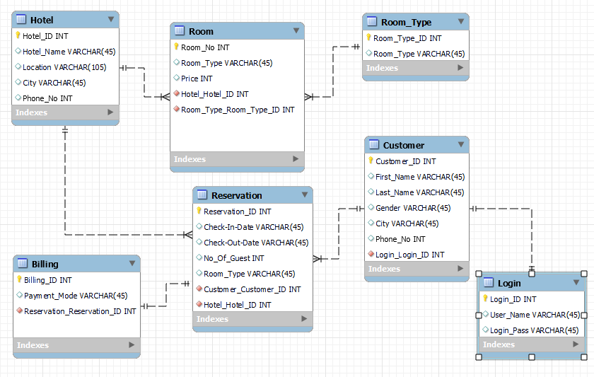

**LOGIN :**

Each Customer have unique Login ID.

**CUSTOMER:**

A Single Customer Can Book SINGLE , MULTIPLE OR ZERO Reservation.

It Pay Multiple Billing for Multiple Bookings.

**RSERVATION:**

A One Reservation have only Single Bill.

Multiple Reservation can be done by Single Customer.

**BILLING:**

Single Bill for Each Reservation.

**HOTEL:**

There are multiple Reservation in Single Hotel.

Each hotel have many Rooms.

**ROOM:**

Each Rooms have many reservation.

Rooms have multiple room_types.

**NORMALIZATION:-**

The EER Diagram is valid for 1NF,2NF and 3NF Rules.

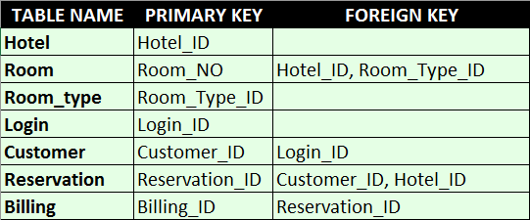

TRIGGER

Creating Trigger on Customer detail so that every time when new customer register in goibibo the system automatically generate login_id and Passward.

create trigger Customer_detail after insert on customer for each row insert into login values(new.Customer_ID, concat(new.First_Name,'_',new.Last_Name),concat(new.First_Name,'@', new.Phone_No));

insert into customer

values(101,'Sanchit','Negi','M','Nainital',98598785);

insert into customer

values(102,'somit','Bhist','M','Nainital',54295623),

(103,'mohit','singh','M','agra',55495623),

(104,'sam','rai','M','Ooty',3545623),

(105,'amit','bhist','M','Prayagraj',5345623),

(106,'dave','m','M','agra',6855623),

(107,'manmohan','chadda','M','Prayagraj',.0325623),

(108,'sanchit','saloni','M','pune',5295623),

(109,'riya','bhatia','F','Noida',6535623),

(110,'deepti','yadav','F','Lucknow',58955421),

(111,'mohini','singh','F','Puri',645312),

(112,'kavita','singh','F','Rishikesh',554210),

(113,'saurah','verma','M','Shimla',0210),

(114,'rohit','mittal','M','Siliguri',5015631),

(116,'shanket','komal','M','Tirupati',4613),

(117,'rohini','singh','F','Udaipur',55222),

(118,'suman','rai','F','Varanasi',054165),

(119,'kamal','bhatia','M','Vijayawada',46310),

(120,'abhi','raj','M','visakhapatnam',511320),

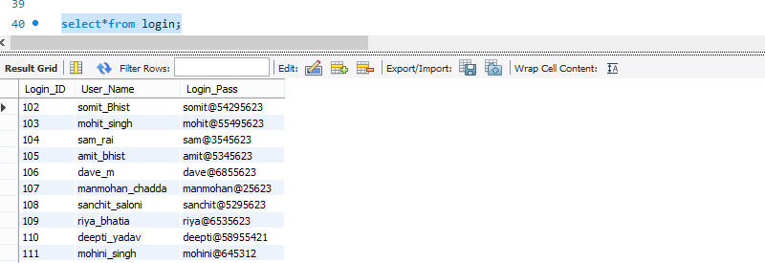 (121,'manoj','gori','M','Ahmedabad',16352);

**STORE PROCEDURE**

**#STORED PROCEDURE TO SHOW TOTAL CITIES LISTED IN HOTEL TABLE:**

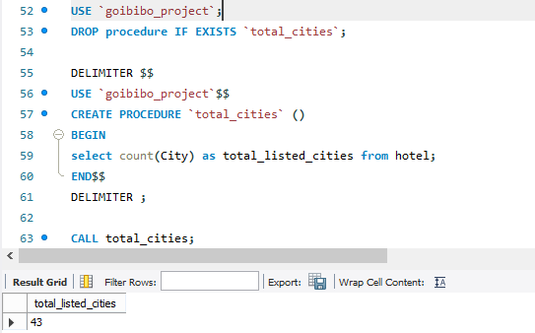

**#STORE PROCEDURE TO CHECK THE MOST EXPENSIVE HOTEL DETAIL:**

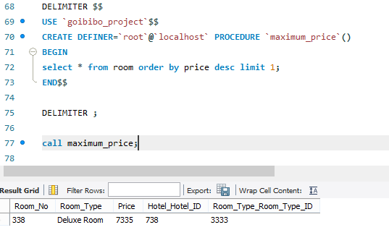

**# STORE PROCEDURE TO DISPLAY TOTAL TYPES OF HOTEL LISTED :**

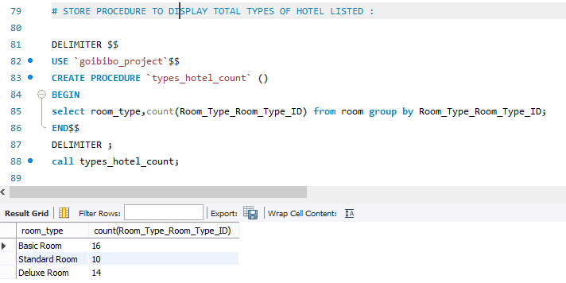

**# STORE PROCEDURE TO CHECK ALL BILLING MODES:**

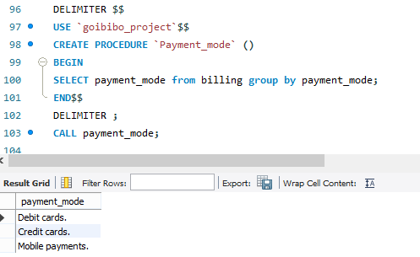

**CREATE INDEX:-**

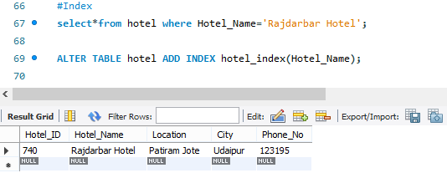

* It acts like a table, so most things you'd do with a table will work with a view
* if you're doing user level access control, you can give a user access to a view without giving them access to the tables behind it
* It allows you to keep the logic centralized, rather than repeating it in your code
* It can allow for massive performance improvements

‍

**CREATE VIEW:**

**CREATE VIEW TO SHOW THE DATA FROM HOTEL,CUSTOMER AND RESERVATION TABLE:**

